London Qualifier, October 29th 2016

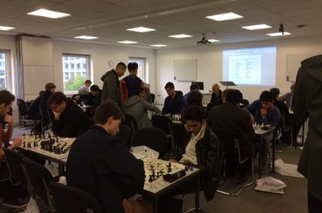
Oxford overcomes opponents in scintillating style!

A record 22 teams entered the London qualifier of the 2020 series, but that didn't stop both Oxford sides impressing as they stormed into the super finals showing themselves to be one of the favourites. Having won the 'National University Chess Championships South' last February, Oxford were determined to display their dominance by sending an even stronger side than last time which showed as they convincingly won all their matches.

They will be joined by UCL and Imperial from the university section, while adult teams 'R2D2' and 'All Stars' made their way through as well, all of them finishing in the top six though some distance behind the eventual winners. However they will nevertheless certainly be a threat to everyone on finals day.

The increase in participants was most delightful, these championships offer the chance for many to access competitive tournaments, and several people either made their debuts for their team or played at their first ever Chess event. Long may it continue!

At the closing ceremony the head of Chess England and Middlesex County Chess Association
Adam Raoof kindly awarded the prizes to round off a tiring but thoroughly enjoyable day!

These events wouldn't have been able to expand like they have done without the help from our sponsors.

Chess & Bridge generously provided each player a gift bag with their latest magazine along with the equipment, prizes and scorecards, and Chess Openings Wizard generously gave three copies of their high quality software programs to the best three players.

We are most grateful for their support.

Many thanks for all those who came making it a success!

Peter Hornsby, 2020 Chess Founder and Director

With the invaluable help of:

Phil Purcell, arbiter

Alex Taylor, arbiter

Katie Raine, site manager

Ben Raine, pairings secretary

Our sponsors who can be found at www.chess.co.uk and www.bookup.com
London 2020 Chess Qualifier
29th October 2016
Proudly Sponsored by Chess & Bridge and Chess Openings Wizard

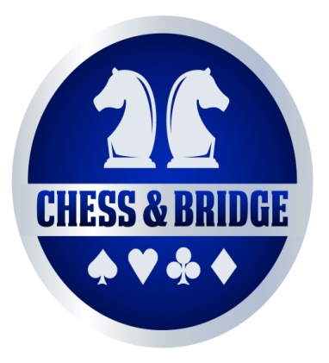

Round One:
Goldsmiths 0-4 Queen Mary's 'B'
Queen Mary's 'C' 0 -4 Imperial 'A'
Imperial 'B' 1-3 R2D2
Reading 0- 4 Kent 'A'
Kent 'B' 2- 2 Royal Holloway
Surrey 'A' 0 -4 LSE 'A'
LSE 'B' 3.5-0.5 Surrey 'B'
UCL 'A' 1 -3 Oxford 'A'
Oxford 'B' 2-2 UCL 'B'
UCL 'C' 1.5- 2.5 Barbarians
Queen Mary's 'A' 0-4 All Stars

Round Two:
Imperial 'A' 0 -4 Oxford 'A'
Kent 'A' 4-0 Barbarians
LSE 'A' 4-0 Queen Mary's 'B'
R2D2 4 -0 LSE 'B'
All Stars 4-0 Kent 'B'
Royal Holloway 1-3 Oxford 'B'
UCL ‘B’ 4-0 Goldsmiths
Reading 0.5 -3.5 UCL 'C'
Surrey 'A' 4-0 Imperial 'B'
Surrey 'B' 1.5-2.5 Queen Mary's 'A'
Queen Mary's 'C' 0-4 UCL 'A'
Round Three:
All Stars 3.5 -0.5 LSE 'A'
Oxford 'A' 3-1 Kent 'A'
Oxford 'B' 3.5-0.5 R2D2
LSE 'B' 0-4 UCL 'B'
Queen Mary's 'B’ 2-2 UCL 'C'
UCL 'A' 2 -2 Imperial 'A'
Queen Mary's 'A' 3-1 Surrey 'A'
Imperial 'B' 1-3 Royal Holloway
Kent 'B' 2-2 Queen Mary's 'C'
Goldsmiths 1.5-2.5 Reading
Barbarians 2.5- 1.5 Surrey ‘B’
Round Four:
Oxford 'A' 3.5-0.5 All Stars
UCL 'B' 2 -2 LSE 'A'
Kent 'A' 2.5-1.5 Oxford 'B'
R2D2 0.5 -3.5 Queen Mary's 'A'
Queen Mary's 'B' 0-4 UCL 'A'
Imperial 'A' 3-1 Royal Holloway
UCL 'C' 4-0 Surrey 'A'
Surrey 'B' 1 -3 Reading
Kent 'B' 0 -4 LSE 'B'
Queen Mary's 'C' 2 - 2 Goldsmiths
Imperial ‘B’ 2 -2 Barbarians
Round Five:
Queen Mary's 'A' 0-4 Oxford 'A'
All Stars 4-0 Kent 'A'
Imperial 'A' 3-1 UCL 'B'
Oxford 'B' 4- 0 UCL 'C'
LSE 'A' 1.5-2.5 UCL 'A'
Reading 0-4 R2D2
LSE 'B' 3-1 Queen Mary's 'B'
Royal Holloway 3 -1 Surrey 'B'
Surrey 'A' 4-0 Queen Mary's 'C'
Imperial 'B’ 4-0 Kent 'B'
Barbarians 2-2 Goldsmiths
Overall League Table:
(Highlighted sides qualify for Super Final)
Team | Played | Wins | Draws | Defeats | Total | Position
Oxford A | 5 | 5 | 0 | 0 | 15 | 1st
All Stars | 5 | 4 | 0 | 1 | 12 | 2nd
Oxford B | 5 | 3 | 1 | 1 | 10 | 3rd
UCL A | 5 | 3 | 1 | 1 | 10 | 4th
Imperial A | 5 | 3 | 1 | 1 | 10 | 5th
R2D2 | 5 | 3 | 0 | 2 | 9 | 6th
Kent A | 5 | 3 | 0 | 2 | 9 | 7th
LSE B | 5 | 3 | 0 | 2 | 9 | 8th
Queen Mary’s A | 5 | 3 | 0 | 2 | 9 | 9th
UCL B | 5 | 2 | 2 | 1 | 8 | 10th
Barbarians | 5 | 2 | 2 | 1 | 8 | 11th
LSE A | 5 | 2 | 1 | 2 | 7 | 12th
UCL C | 5 | 2 | 1 | 2 | 7 | 13th
Royal Holloway | 5 | 2 | 1 | 2 | 7 | 14th
Surrey A | 5 | 2 | 0 | 3 | 6 | 15th
Reading | 5 | 2 | 0 | 3 | 6 | 16th
Imperial B | 5 | 1 | 1 | 3 | 4 | 17th
Queen Mary’s B | 5 | 1 | 1 | 3 | 4 | 18th
Goldsmiths | 5 | 0 | 2 | 3 | 2 | 19th
Kent B | 5 | 0 | 2 | 3 | 2 | 20nd
Queen Mary’s C | 5 | 0 | 2 | 3 | 2 | 21st
Surrey B | 5 | 0 | 0 | 5 | 0 | 22nd

Individual Results:
(Highlighted in yellow=bronze medal, grey=silver medal, orange= gold medal)

