2020 Yorkshire Qualifier, Leeds December 2nd 2017-18
Lethal York cruise to victory in an outstanding display!
York Society became the first team in 2020 history to score a perfect 20/20 in individual game points thus defeating all their opponents by a 4-0 scoreline in the process.
Although the challengers did fight hard they were clearly overwhelmed, as one of the early favourites and hosts Leeds A found out only in the first round where they were well beaten on each board. York continued in the same vain outclassing Sunderland and the rest of the Leeds’ teams over the next three rounds.
Durham had started in a similar vein of form with comfortable 4-0 wins over the same opponents before facing Leeds A in round four needing a victory to stay in contention for the title. They took an early lead before being pegged back to 2-1 with all to play for on the top board where Liza Kisteneva (Durham) and Robert Starley (Leeds A) faced off in an epic battle in an endgame with time constraints with the whole audience eventually looking on.
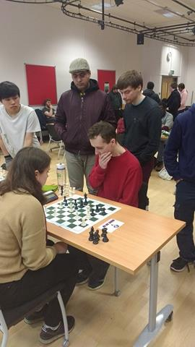
Liza finally found a small advantage and capitalised with just seconds left on the clock to seal victory in a dramatic finish ensuring that there would be a final showdown against York in the concluding round to much applause from everyone in the playing hall. Durham had faced Leeds back in June 2015 at the first ever Northern Universities Chess Championships (later developing into 2020 Chess) narrowly prevailing on higher boards so York were in the mood for sweet revenge.
As Durham had dropped a game point against Leeds they had to beat York to claim the title, but their opponents were in fine form and despite a valiant fight from Durham they eventually prevailed on all four boards to deservedly claim the title and make history.
Meanwhile all the remaining teams had a chance of qualifying for the Grand Final if results went their way in the final round. It was a tough ask for debutants Sunderland against Leeds A and although they claimed a win on board three it wasn’t enough as they were eliminated through a 3-1 defeat. Leeds B kept true to their name with a dominant victory over Leeds C to secure the final qualifying spot.
Many thanks to Nathalie Taylor who assisted with the pairings and organising on the day, as well as to all our sponsors; Chess and Bridge, Chess Openings Wizard, Internet Chess Club for their support providing equipment and prizes enabling fantastic events like these to take place along with Robert Starley and Leeds Chess Society for booking the venue and hosting the event we look forward to returning next year hopefully!
Congratulations to those who won bronze medals for scoring 4/5:
Liza Kisteneva (Durham)
Arsenios Hadjikyriacou (Durham)
Melvin Cheung (Durham)
Marat Ibraimov (Leeds)
And especially to the York team members who won all 5/5 matches:
Sam Chow
Pawel Golimowski
Siyuan Huang
Tom Leah

Round One:
York 4-0 Leeds A
Leeds C 0-4 Durham
Leeds B 3-1 Sunderland
Round Two:
Durham 4-0 Leeds B
Leeds A 4-0 Leeds C
York 4-0 Sunderland
Round Three:
Sunderland 0-4 Durham
Leeds B 0-4 Leeds A
Leeds C 0-4 York
Round Four:
Durham A 3-1 Leeds A
Sunderland 2-2 Leeds C
York 4-0 Leeds B
Round Five:
Leeds A 3-1 Sunderland
Durham 0-4 York
Leeds B 3-1 Leeds C

